Practicum Case | 
MATH6183 | MATH6183001 | MATH6183016 | MATH6183049
Scientific Computing
Mathematics & Statistics | E231-MATH6183-JJ01-02
Valid on Even Semester Year 2022/2023 | Revision 00

Learning Outcomes
- LO2 – solve the systems of linear algebraic equations, eigenvalues, eigenvectors, regression and interpolation through scientific computation

Topic
- Session 02 – System of Linear Equation

Subtopics
- Gauss-Seidel Linear Equation
- NumPy

Soal
Case

Solving Linear Equation
Solve the following system of linear equations with the following requirements:
- You must determine whether the equations are diagonally dominant programmatically. If the equation is not diagonal, then print error message.
- If the equations are diagonally dominant, use Gauss-Seidel method and the number 15 as the maximum iterations. Otherwise, show a message telling the equations are not diagonally dominant.
- Use a pre-defined threshold $ϵ=0.022$
- Use the value 0 as the initial value of x₁, x₂, x₃, and x₄.
Then, show the result for each equations and check whether the equations below are convergent or not and print the value of x1, x2, x3, and x4 in each iteration.
Below are the systems of linear equations that you need to solve:

$$4x_{1}+2x_{2}-x_{3}=41 \\ x_{1}-5x_{2}{+2x}_{3}=-10 \\ 2x_{1}- x_{2}-4x_{3}=1$$

$$3x_{1}+4x_{2}+5x_{3}=34 \\ {-3x}_{1}+7x_{2}-4x_{3}=-32$$
$$x_{1}-4x_{2}-2x_{3}=62$$

$$9x_{1}-2x_{2}+3x_{3}+2x_{4}=55 \\ 2x_{1}+8x_{2}-2x_{3}+3x_{4}=-14$$
$${-3x}_{1}+{2x}_{2}+11x_{3}-4x_{4}=12$$
$${-2x}_{1}+3x_{2}+2x_{3}+10x_{4}=-21$$

Below are the snippet code for the equations above:
Xs = [
[
[4, 2, -1],
[1, -5, 2],
[2, -1, -4]
],
[
[3, 4, 5],
[-3, 7, -4],
[1, -4, -2]
],
[
[9, -2, 3, 2],
[2, 8, -2, 3],
[-3, 2, 11, -4],
[-2, 3, 2, 10]
]
]
Ys = [
[41, -10, 1],
[34, -32, 62],
[55, -14, 12, -21]
]
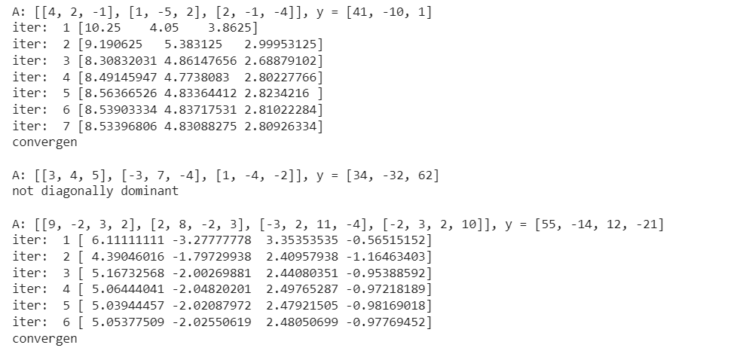
Figure 1. Gauss Seidel Result with Epsilon 0.022

